#### Railway Reservation- Payment

Assumptions:

* The payment for a particular PNR is done only when the status is ‘CONFIRMED’. This should be done in reservation time.
* The payment login screen accepts username and password added by registration in ticket reservation section.
* The following table consists of certain data :-
* YFDB – final database of irctc
* YPDB – passenger check data
* YPDBD – passenger data
* YTDB – train database
* YUPI – upi details
* YATMCARD –atm card details
* YPAYTM- paytm details
* Since real time OTP on phone is not possible on this server because of restrictions, hence a separate column for OTP has been defined in respective payment database tables.

1)Login screen – Here the fields are mandatory. But we can exit by clicking the ‘Exit’ pushbutton as it has ‘At Exit’ command function .

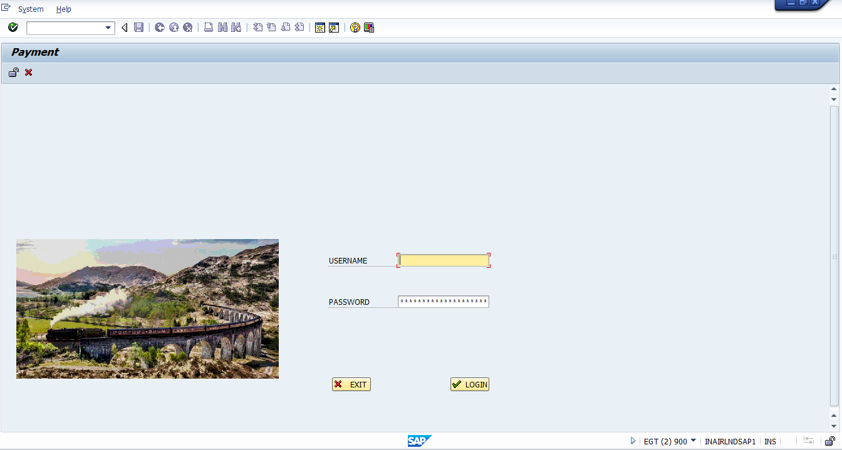

2) 2nd screen has the records of user’s bookings with the status on OOALV. On selecting a particular row and then clicking ‘Details’ takes us to a screen which shows an OOALV of train details.

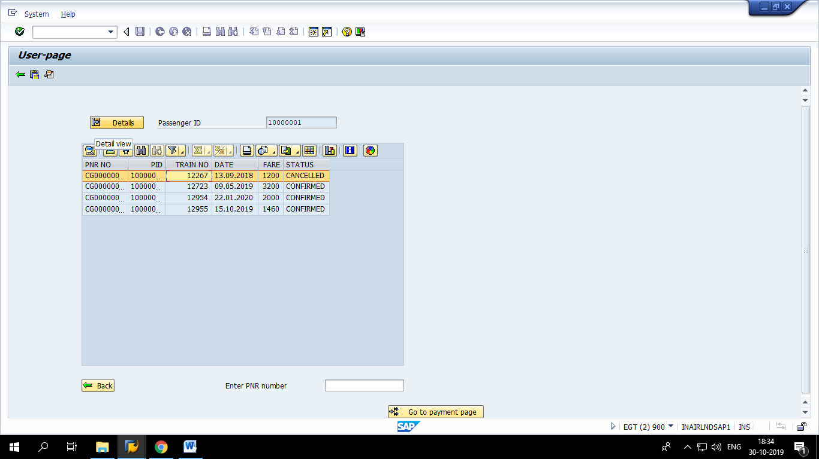

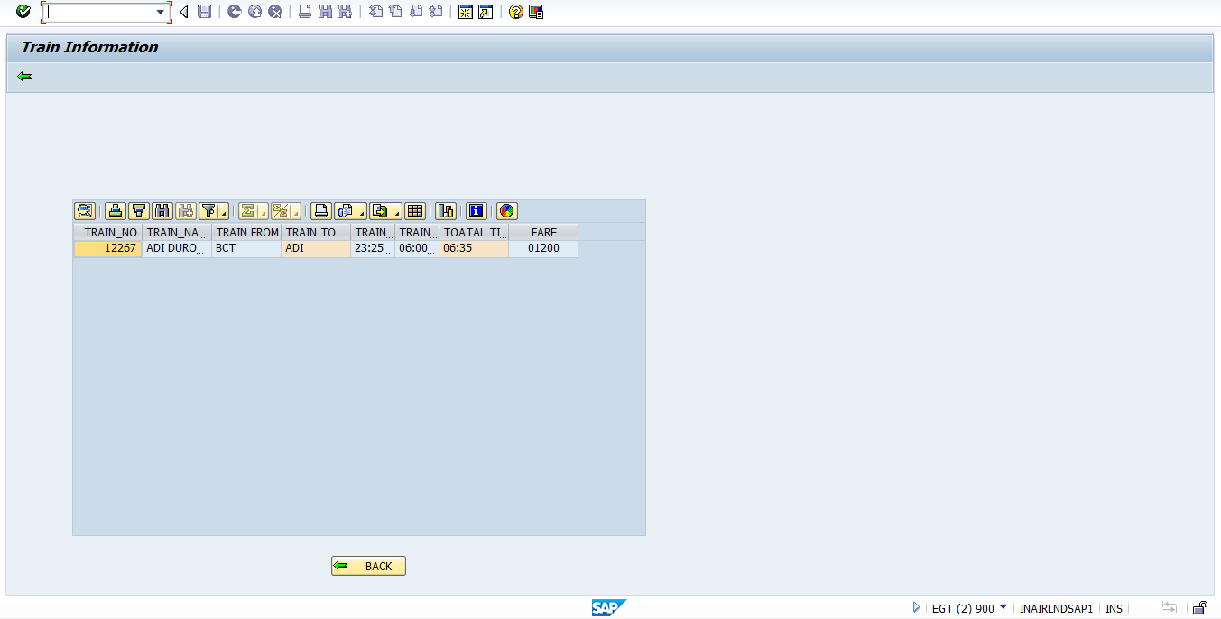

3) Write PNR of which the payment is to be done.

If the status for a particular PNR is ‘PAID’ or ‘CANCELLED’, then on clicking ‘Go to payment page’ push button will trigger message.

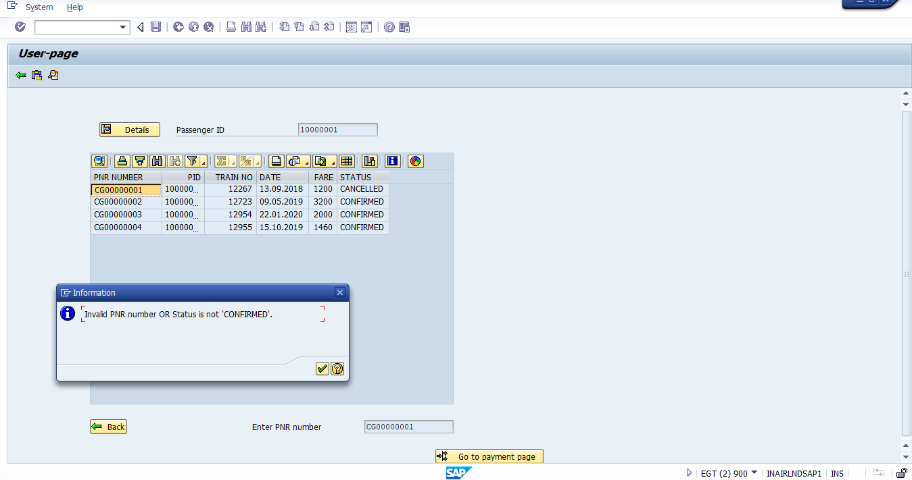

On writing the PNR of field with status as ‘CONFIRMED’, we will be directed to next screen.

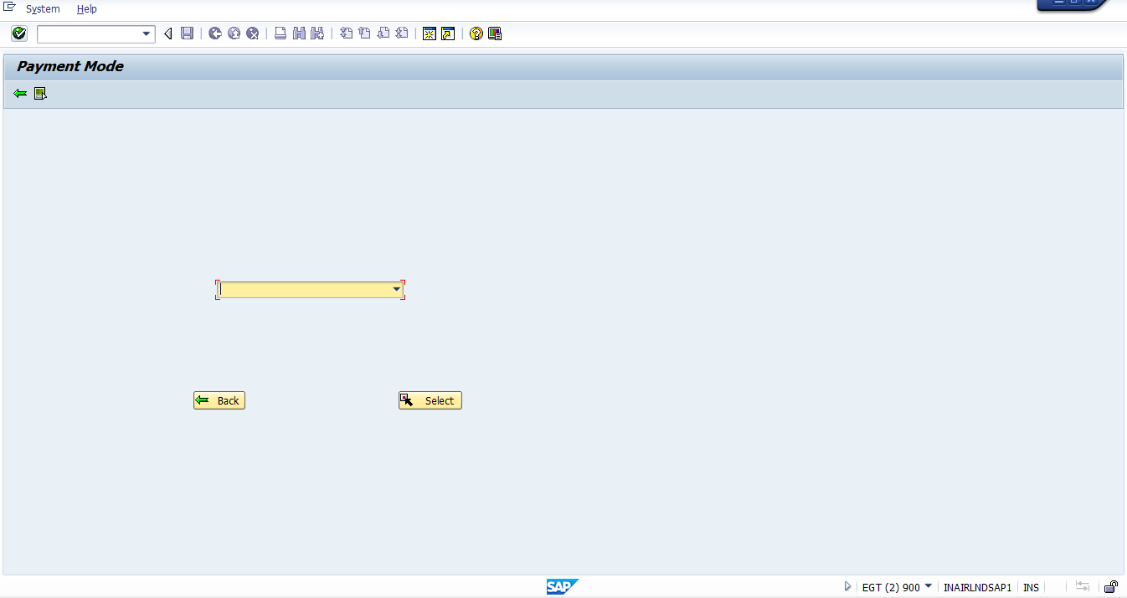

4) Select the mode of payment from the drop down list and click ‘Select’ push button.

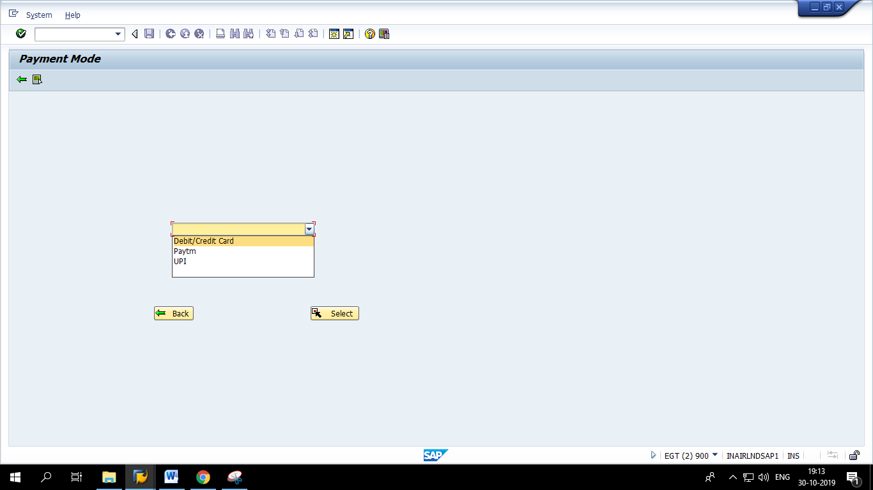

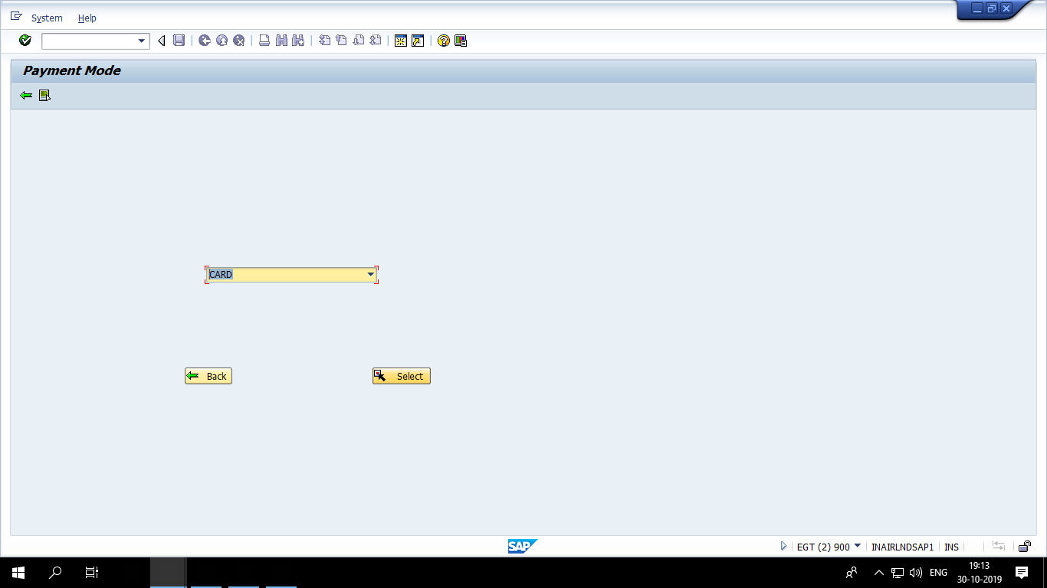

5) I selected ‘Debit/Credit Card’ option from dropdown list. Fill the correct details, otherwise it will show error like:

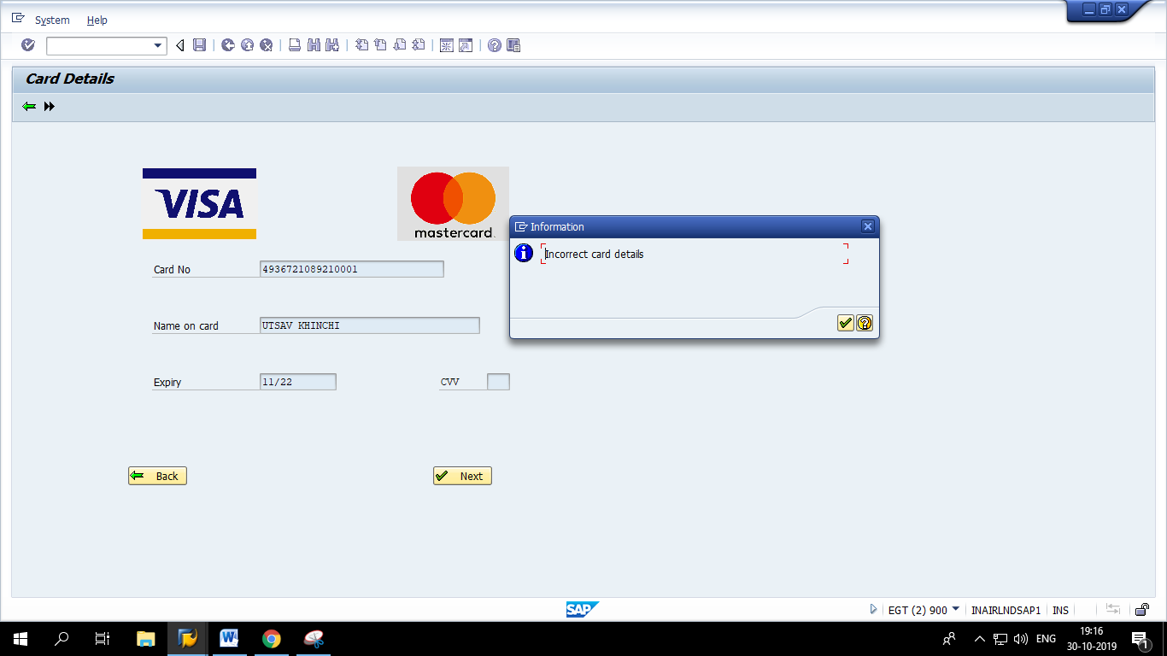

After writing correct details, click ‘Next’. We will be directed to screen asking for OTP.

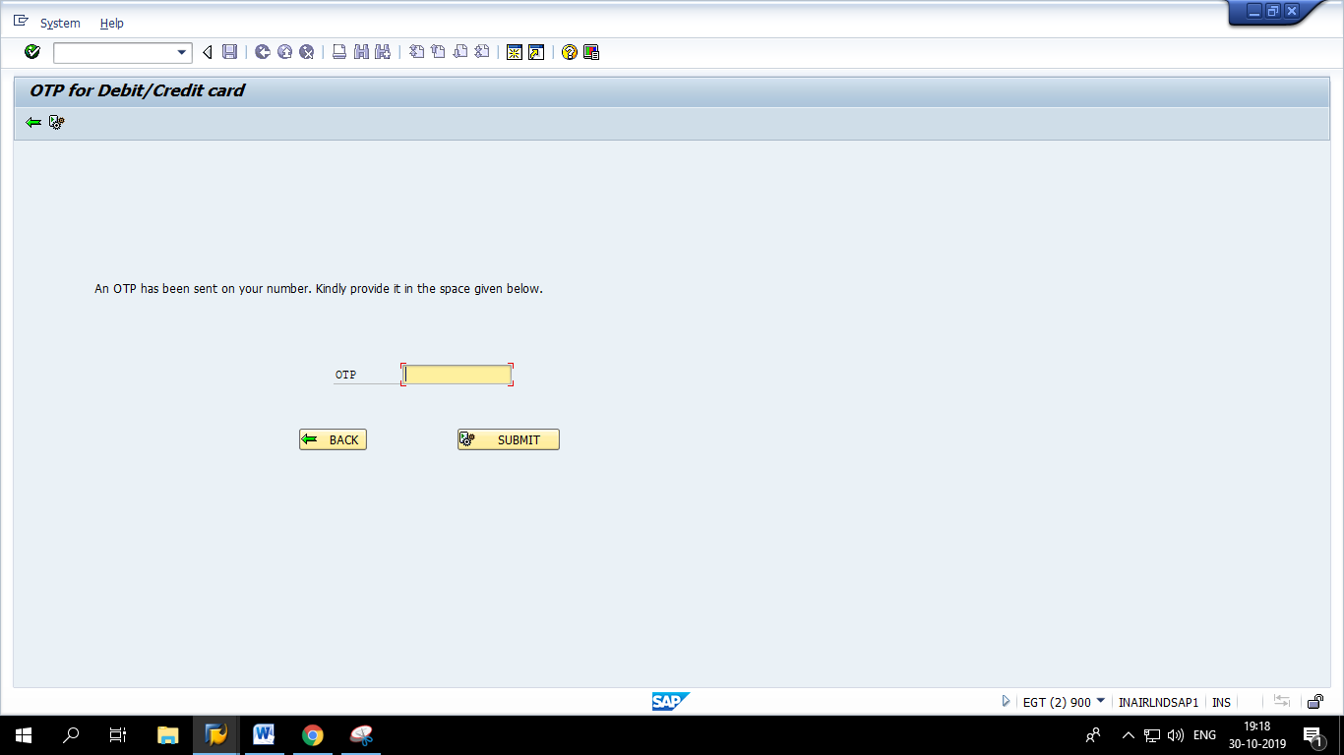

Correct:

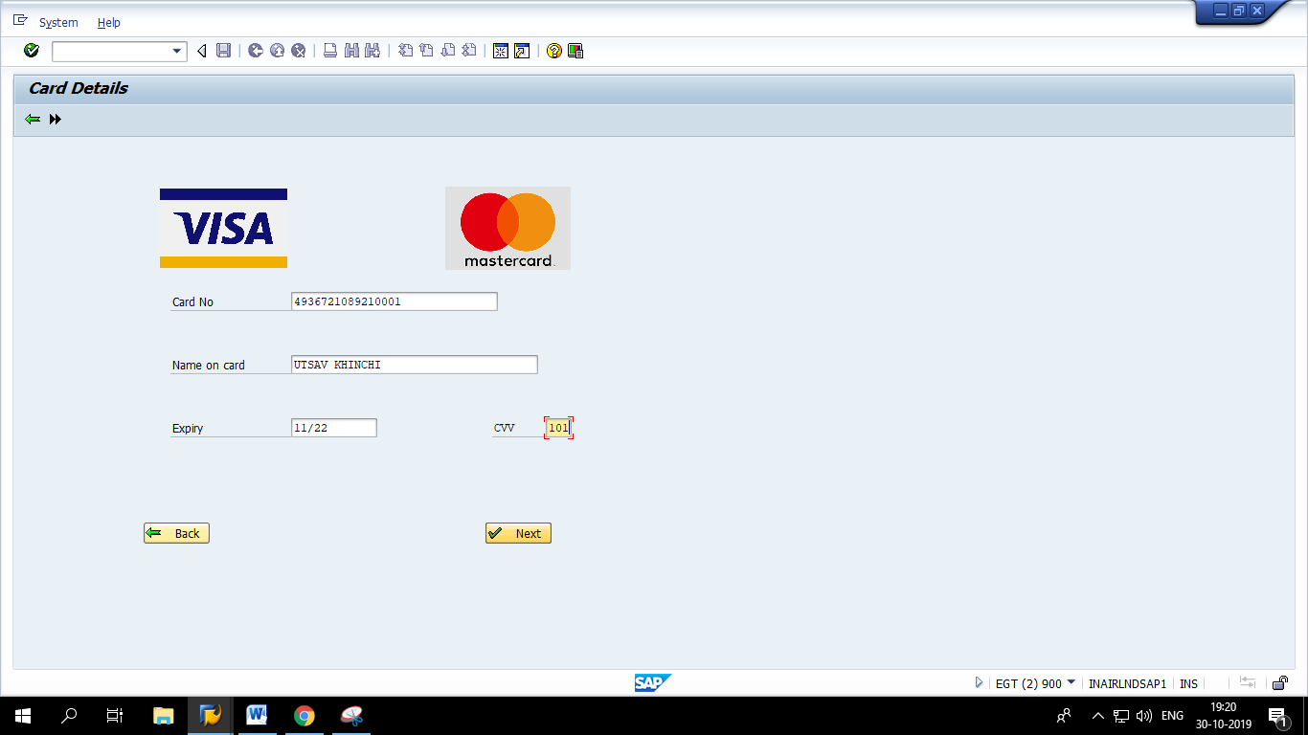

6) Write correct OTP, otherwise it will show error like:

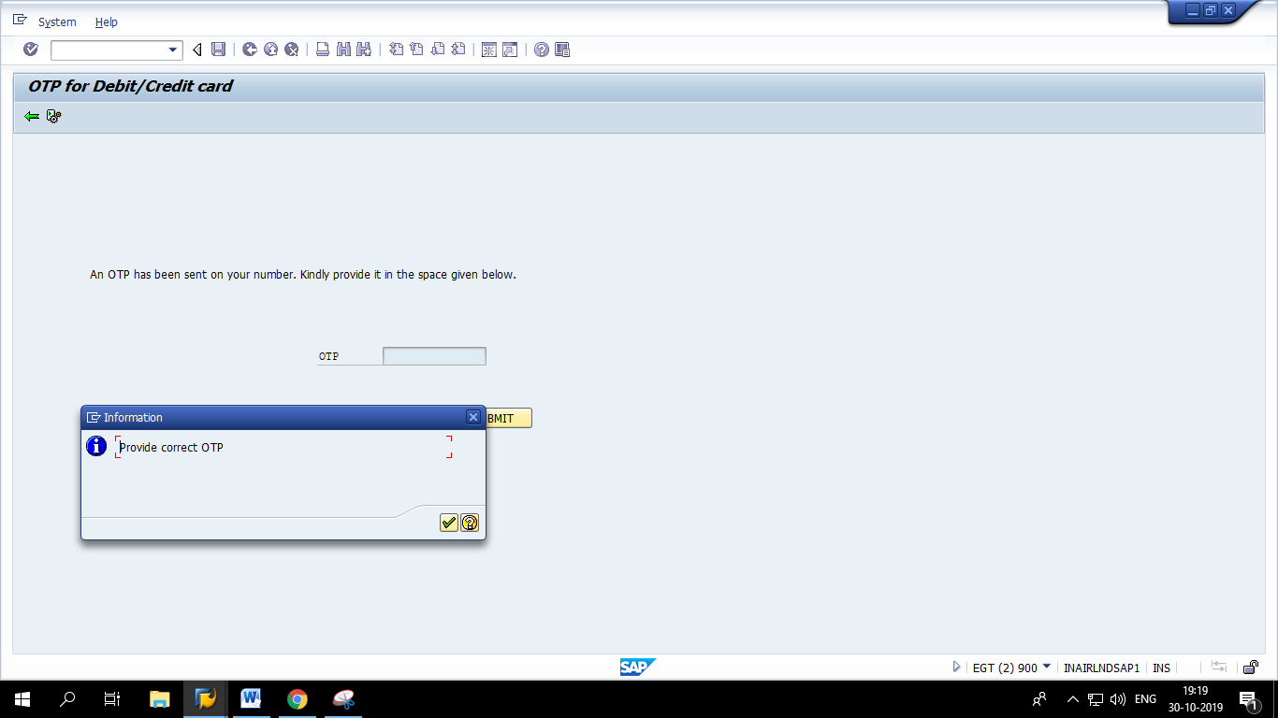

Correct:

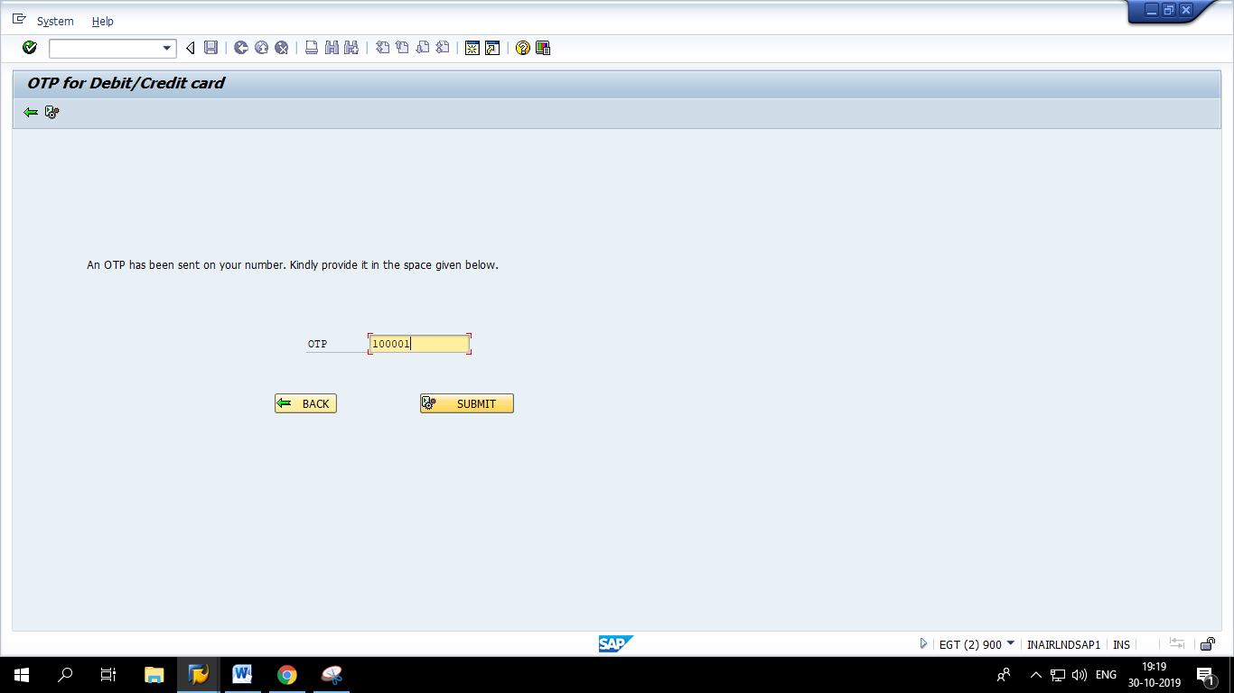

7) Click ‘Submit’ and we will be directed to payment confirmation screen.

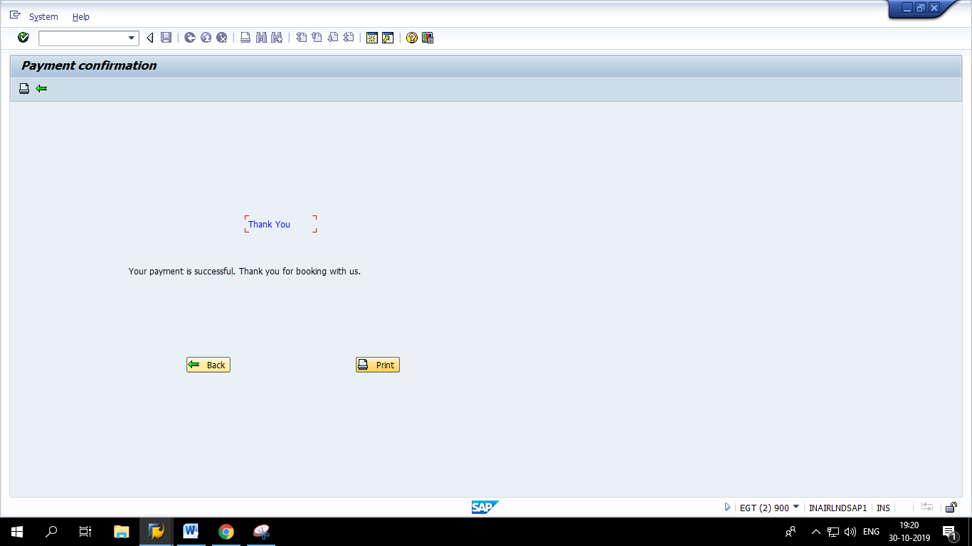

Click ‘Print’ pushbutton to get the Adobe form of INVOICE .

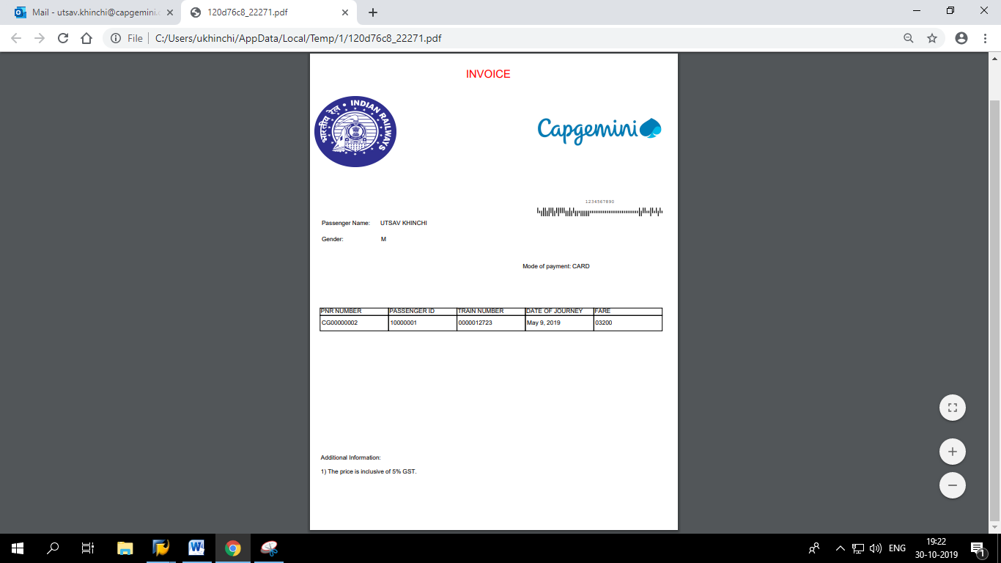

8) Login again with the same user and observe the passenger booking data. You will observe that the status of PNR ‘CG00000002’ has changed from ‘CONFIRMED’ to ‘PAID’.

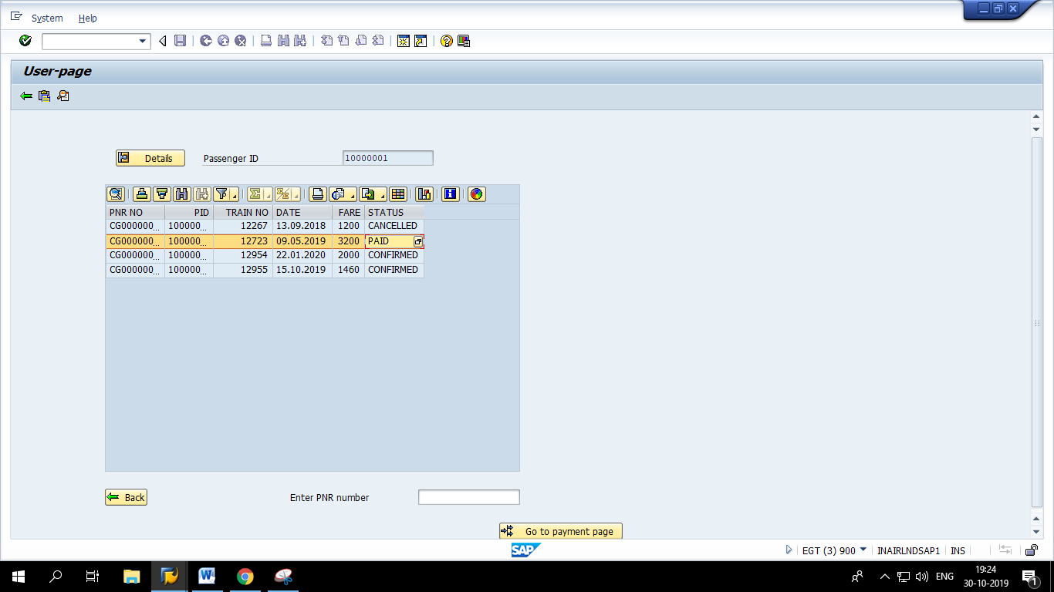

Same can be done for ‘Paytm’ and ‘UPI’.